An Internship Report
Of
Web Development

Submitted
To
School of Computer Science and Engineering
IILM University, Greater Noida, U.P.

In partial fulfilment of the requirement of degree of
B-Tech (CSE)



By

Roll Number of Student: - 25SCS1003000981
Name of Student: ANIKET YADAV

Batch: 2026-27

CANDIDATE'S DECLARATION
I, ANIKET YADAV, do hereby declare that the internship report titled “Web Development” has been completed by me to fulfil the requirement for the award of the degree of Bachelor of Technology in Computer Science and Engineering. All the references have been quoted and I have not taken as such any material from any other source. I affirm that this report is my own and has not been submitted to any other institute for any degree/diploma requirement, and further I shall be solely responsible for any kind of copyright violation in this regard.
Signature: -

Student Name: ANIKET YADAV

Roll No.: 25SCS1003000981

ACKNOWLEDGEMENT
I am using this opportunity to express my gratitude to everyone who supported me throughout the Internship Program. I am thankful for their aspiring guidance, invaluably constructive criticism, and friendly advice during this work. I am sincerely grateful to them for sharing their truthful and illuminating views on a number of issues related to this work.
I would like to thank Sieve Capital for providing me the opportunity and the structured environment to learn and gain hands-on exposure in the domain of Web Development. I am also thankful to my institute, IILM University, Greater Noida, and the faculty of the School of Computer Science and Engineering for their continuous support and encouragement.

Signature:

Student Name: ANIKET YADAV

Roll No.: 25SCS1003000981

TABLE OF CONTENTS
1. Candidate's Declaration ii
2. Acknowledgement iii
3. Internship Completion Certificate iv
4. Project Description 1
4.1 Introduction 1
4.2 Organization Profile 1
4.3 Problem Statement 2
4.4 Project Objectives 2
4.5 Scope of the Project 3
4.6 Technologies and Tools Used 3
4.7 System Architecture 3
4.8 Methodology 4
4.9 Expected Outcomes 4
4.10 Certificates of Completion and Communication Proof 5
5. Bibliography/References 6
3. INTERNSHIP COMPLETION CERTIFICATE
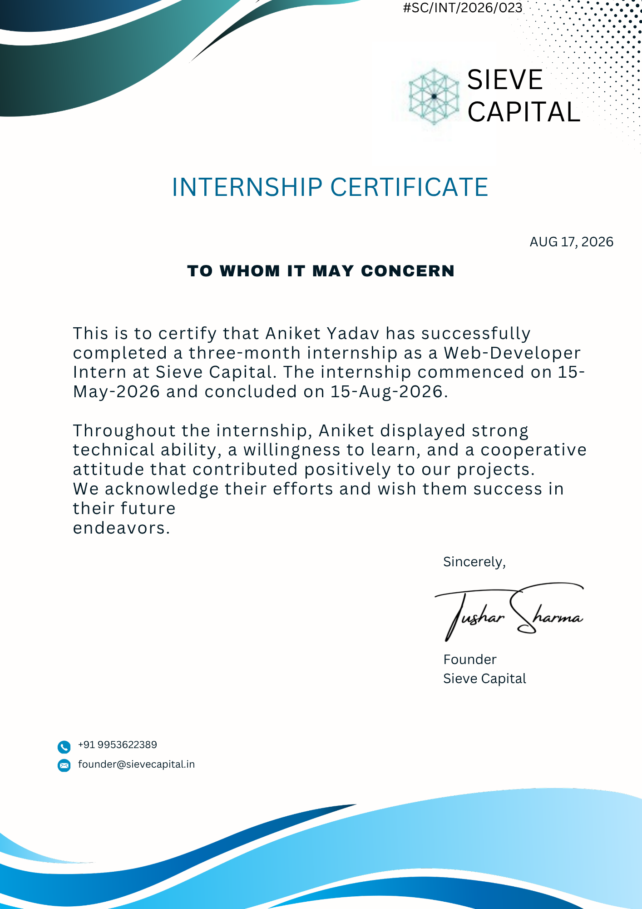

4. PROJECT DESCRIPTION

4.1 Introduction
This report presents a detailed account of the three-month Internship undertaken at Sieve Capital, in the domain of “Web Development”. The internship was carried out from 15 May 2026 to 15 August 2026 as part of the requirement for the award of the degree of Bachelor of Technology in Computer Science and Engineering at IILM University, Greater Noida.
The primary aim of this internship was to bridge the gap between theoretical software engineering concepts and real-world, production-grade web application development. Over the course of the program, practical exposure was gained in industry-standard tools, modern frontend and backend frameworks, database management systems, and cloud deployment practices necessary to build and maintain scalable, secure web applications.
The internship combined hands-on project execution, core development tasks, code reviews, and continuous team collaboration. Upon successful completion of all assigned requirements and deliverables, an Internship Completion Certificate was awarded by Sieve Capital.

4.2 Organization Profile
Sieve Capital is a tech-driven venture and investment firm that leverages modern software engineering and automation solutions to optimize financial and operational workflows. The company focuses on building high-performance digital platforms, proprietary tools, and data-driven systems.
Through its technical internship initiatives, Sieve Capital provides engineering students and early-career developers with direct, hands-on exposure to production-grade software development. Interns at Sieve Capital work alongside experienced technical teams to gain practical experience in full-stack web development, API engineering, database design, and cloud infrastructure management, equipping them with essential industry-ready skill sets.
4.3 Problem Statement
Although many engineering students learn core programming and theoretical concepts during their academic coursework, very few gain exposure to the practices required to build and deploy production-ready web applications. Writing basic code is only one part of software development; delivering a secure, responsive, scalable, and maintainable website that serves real business needs is an equally important and often overlooked skill. The core objective of this internship was to bridge this gap by contributing directly to the design, frontend development, backend integration, and deployment of Sieve Capital's official company website, ensuring standard web conventions, optimal performance, and clean UI/UX design.
4.4 Project Objectives
- To understand the end-to-end web development lifecycle and industry-standard workflows used in production environments.
- To design and build modern, responsive user interfaces using HTML5, CSS3/Tailwind CSS, and JavaScript frameworks.
- To assist in company website development, focusing on smooth navigation, cross-browser compatibility, and mobile responsiveness.
- To apply state management techniques for seamless data flow across user-facing pages and administrative interfaces.
- To deploy web applications using cloud hosting platforms and manage version control via Git/GitHub.
- To optimize web performance, SEO, and security best practices (such as authentication and data encryption).

4.5 Scope of the Project
The scope of this internship spans the full software development lifecycle for web applications—starting from initial UI/UX wireframing, frontend development, backend API architecture, database integration, and final deployment. The work primarily focused on assisting in the development, styling, and optimization of Sieve Capital’s company website. The scope also included setting up responsive web pages, handling client-side and server-side logic, implementing secure routing, and ensuring optimal loading speeds across devices.
4.6 Technologies and Tools Used
- Frontend Development: HTML5, CSS3, JavaScript (ES6+).
- Version Control & Collaboration: Git, GitHub
- Hosting & Deployment: Vercel.
- Development Tools: VS Code, Chrome Developer Tools, Gemini AI
4.7 System Architecture
The general architecture followed during the development of the web applications and company website can be summarized in the following layers:
- Presentation Layer (Frontend): Built using modern UI frameworks (React.js/HTML/CSS) to handle user interactions, render responsive layouts, and manage dynamic views.
- API & Business Logic Layer (Backend): Powered by server-side technology to handle incoming HTTP requests, process business logic, perform validation, and route data securely.

4.8 Methodology
The internship was structured around an iterative software development methodology (Agile/Scrum principles), focusing on direct code execution, weekly sprints, code reviews, and continuous integration. Over the 3-month duration at Sieve Capital, the work progressed through specific development phases as detailed below:
Week | Focus Area | Description
1-2 | Onboarding & Environment Setup | Codebase orientation, setting up local development environments, version control (Git) workflow configuration, and reviewing UI/UX design specifications for the company website.
3-5 | Frontend Architecture & Layout | Building responsive UI components using HTML5, CSS, and JavaScript. Ensuring mobile responsiveness and cross-browser compatibility across standard breakpoints.
6-8 | Backend API & Database Integration | Developing and testing RESTful API endpoints, establishing database connectivity (MongoDB/PostgreSQL), and integrating dynamic content flows into the frontend interface.
9-10 | Testing & Optimization | Conducting cross-device usability testing, fixing layout bugs, optimizing web asset loading speeds, and implementing basic web security and SEO best practices.
11-12 | Deployment & Documentation | Assisting in deploying build artifacts to staging/production servers, configuring CI/CD deployment triggers, and finalizing technical documentation and codebase handoff.

Regular stand-ups and technical feedback sessions were conducted throughout the tenure to review pull requests, address blockers, and ensure project deliverables met production standards.
4.9 Expected Outcomes
- Practical Software Development Experience: Gained hands-on experience in building, structuring, and maintaining a production-grade web application.
- Frontend Proficiency: Mastered responsive web design principles and modern component-based UI development.
- Version Control & Collaboration: Built fluency in collaborative development using Git workflows, branch management, and pull request reviews within an engineering team.
- Deployment & Best Practices: Learned standard deployment procedures, web performance optimization methods, and essential security practices.
4.10 Certificates of Completion and Communication Proof
The official Internship Completion Certificate issued by Sieve Capital, confirming the successful completion of the three-month Web Developer Internship program, is attached in the relevant appendix/section of this report.
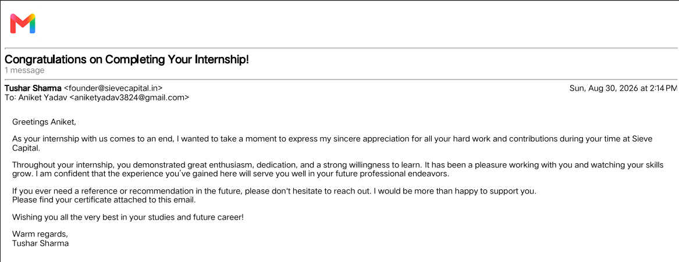
5. BIBLIOGRAPHY/REFERENCES

- Sieve Capital, “Internship Completion Certificate – Web Development Internship,” Certificate Ref No. #SC/INT/2026/021, Issued on August 17, 2026.
- MDN Web Docs, HTML5, CSS3, and JavaScript Standard Reference, https://developer.mozilla.org/
- React Documentation, Official React.js Library Guide, https://react.dev/
- Node.js & Express.js Documentation, Server-Side Application Frameworks, https://expressjs.com/
- Tailwind CSS Documentation, Utility-First CSS Framework Reference, https://tailwindcss.com/docs
- Git & GitHub Documentation, Version Control System Practices, https://git-scm.com/doc

